

A MINI-PROJECT REPORT ON

“AI-Based Network Intrusion Detection System with Honeypot Integration”
Submitted in partial fulfilment of the requirements for the award of the Degree
of

BACHELOR OF TECHNOLOGY IN
COMPUTER SCIENCE AND ENGINEERING
(ARTIFICIAL INTELLIGENCE AND MACHINE LEARNING)

Submitted by

M KARTHIKESHWAR(R23EA067)
SAI HEMANTH(R23EA102)

Under the guidance of
DR.SANJU V
Professor, School of CSE

REVA University
Rukmini Knowledge Park, Kattigenahalli, Yelahanka,Bengaluru-560064 www.reva.edu.in
May 2026

DECLARATION

We, M KARTHIKESHWAR(R23EA067), SAI HEMANTH(R23EA102)
students of B.Tech., VI Semester, School of Computer Science and Engineering, REVA University declare that the Mini-Project Report entitled “AI-Based Network Intrusion Detection System with Honeypot Integration” is done by us under the guidance of DR.SANJU V, Professor School of Computer Science and Engineering, REVA University.
The Mini-Project Report is submitted in partial fulfilment of the requirements for the award of the degree of Bachelor of Technology in Computer Science and Engineering (Artificial Intelligence and Machine Learning) by the REVA University, Bengaluru during the academic year 2025-26.
We further declare that the Mini-Project or any part of it has not been submitted for award of any other Degree of REVA University or any other University / Institution.

- M KARTHIKESHWAR (R23EA067) –
- SAI HEMANTH(R23EA102) –

SCHOOL OF COMPUTER SCIENCE AND ENGINEERING

CERTIFICATE

This is to certify that the Mini-Project entitled “AI-Based Network Intrusion Detection System with Honeypot Integration” is carried out under my guidance by M KARTHIKESHWAR(R23EA067), SAI HEMANTH(R23EA102) bonafide students of REVA University during the academic year 2025-26. The above-mentioned students are submitting the Mini-Project report in partial fulfilment for the award of Bachelor of Technology in Computer Science and Engineering (Artificial Intelligence and Machine Learning) during the academic year 2025-26. The Mini-Project report has been approved as it satisfies the academic requirements in respect of Mini-Project work prescribed for the said degree.

Signature with date Signature with date
Guide Director (I/C)

Name of the Examiner Signature with Date

- ​

- ​

The AI-Powered Legal Assistant is an intelligent legal support system designed to assist users in understanding legal issues using Artificial Intelligence, Natural Language Processing (NLP), semantic retrieval, and Large Language Models (LLMs). The system analyzes user legal queries and retrieves relevant Indian Penal Code (IPC) sections along with similar case laws from legal datasets. The retrieved legal information is then processed using a Large Language Model to generate structured legal analysis, simplified explanations, severity assessment, and recommended legal actions.

The system follows a hybrid Retrieval-Augmented Generation (RAG) architecture where semantic similarity techniques are combined with AI reasoning to improve legal accuracy and reduce hallucinated responses. A role-based interface is implemented for both citizens and lawyers. Lawyer mode additionally provides estimated legal timelines, cross-examination questions, document comparison, and legal probability prediction.

The backend of the system is developed using FastAPI while the frontend interface is designed using Streamlit. Sentence-transformers are used for semantic embedding generation and Ollama-based LLM integration is used for reasoning and response generation. The system demonstrates the practical application of AI in legal technology by improving accessibility, explainability, and efficiency of legal information retrieval.

Keywords
Key Words:Artificial Intelligence, Natural Language Processing, Retrieval-Augmented Generation, Large Language Models, Semantic Search, Legal Information Retrieval, Indian Penal Code, Case Law Analysis, FastAPI, Streamlit.

We would like to express our deepest gratitude to Dr. P. Shyama Raju, honourable Chancellor for providing us the necessary facilities for the successful completion of Mini-Project. We would also like to acknowledge Mr. Umesh S. Raju, Pro Chancellor, Dr. Sanjay R. Chitnis, Vice-Chancellor, Dr. K S Narayanaswamy, Pro Vice-Chancellor and Dr. M. Dhanamjaya, Registrar for their constant support and endorsement through invaluable administration.
In the same breath, we would also like to mention our sincere gratitude to Dr.Sarvamangala D R, Director (I/C), School of Computer Science and Engineering for her constant support and encouragement. We would like to express our deepest gratitude to Dr. T. Prasanth, Mini-Project Coordinator for giving us an opportunity to take up the Mini-Project.
We wish to record our deep sense of gratitude and profound thanks to our guide
DR.SANJU V, Professor, School of Computer Science and Engineering, REVA University for his/her keen interest, inspiring guidance, constant encouragement with my work during all stages, to bring the Mini-Project report into fruition

Finally, we thank the almighty, our parent, siblings, family members and friends for their moral support during our Mini-Project work.

TABLE OF CONTENTS
DECLARATION ii
CERTIFICATE iii
ABSTRACT iv
ACKNOWLEDGEMENTS v
TABLE OF CONTENTS vii
List of Tables ix
List of Figures x
LIST OF ABBREVIATIONS xi
CHAPTER 1 INTRODUCTION 1
  - Overview and motivation 1
  - Problem Statement: 1
  - Objectives: 2
  - Scope of the project 2
  - Significance of the project 3
CHAPTER 2 LITERATURE REVIEW 4
  - AI-Based Intrusion Detection Systems 4
    - Machine Learning-Based IDS 6
    - Deep Learning-Based IDS 7
  - Deep Learning IDS 7
  - Explainable AI 8
  - Federated Learning 8
  - Hybrid IDS Models 8
  - Research gap 9
CHAPTER 3 TOOLS AND METHODOLOGY 10
  - Tools and Technologies Used 10
    - Packet Capture 10
    - Feature Extraction 11
  - Machine Learning Model 11
  - Behavior Analysis 11
  - Honeypot Integration 12
  - Dashboard Development 12
  - Data Storage 12
3.7 Implementation Workflow 13
CHAPTER 4 RESULTS AND DISCUSSION 15
  - IDS Dashboard Output 15
    - Attack Alert Visualization 15
    - Traffic Statistics and Monitoring 16
  - Honeypot Login Page 16
  - Traffic Logs and Analysis 16
  - Attack Detection Results 17
  - System Performance 17
  - Advantages 18
  - Limitations 18
CHAPTER 5 CONCLUSION 19
  - Conclusion on results 19
  - Recommendations 19
  - Future scope 20
REFERENCES 21

PUBLICATIONS / PATENT FILING / APP DEVELOPMENT PROOF…………..22

LIST OF TABLES

TABLE NO | TITLE | PAGE NO
TABLE 2.1 | Literature Survey Comparision | 6

LIST OF FIGURES

FIGURE NO | TITLE | PAGE NO
Figure 3.1 | System Architecture Diagram | 14
Figure 8.1 | IDS Dashboard with Attack Detection | 15
Figure 8.2 | Honeypot Login Page | 16
Figure 8.3 | Traffic logs and trend analysis | 17

LIST OF ABBREVIATIONS

ABBREVATION | MEANING
IDS | Intrusion Detection System
TCP | Transmission Control Protocol
UDP | User Datagram Protocol
TTL | Time-To-Live
DDoS | Distributed Denial of Service
IoT | Internet of Things

Overview and motivation
AI-Powered Legal Assistant is an intelligent legal support system developed using Artificial Intelligence, Natural Language Processing (NLP), semantic retrieval, and Large Language Models (LLMs). The system allows users to submit legal queries in natural language and automatically retrieves relevant IPC sections and similar legal case laws from legal datasets. The retrieved information is then processed using a Retrieval-Augmented Generation (RAG) architecture to generate structured legal analysis, simplified explanations, severity assessment, and recommended legal actions. The platform is designed for both citizens and lawyers through a role-based interface.

The system uses Streamlit for the frontend interface and FastAPI for backend processing and API communication. Sentence-transformers are used to generate semantic embeddings for contextual legal retrieval, while LLaMA 3 through Ollama is used for reasoning and response generation. In Lawyer mode, the system additionally provides advanced legal insights such as estimated legal timelines, cross-examination questions, document comparison, and legal probability prediction. These features improve the usefulness of the system for legal professionals and legal research purposes.
The motivation behind developing this project comes from the difficulty faced by ordinary individuals in understanding legal procedures and accessing legal guidance. Traditional legal search systems mainly depend on keyword-based retrieval techniques, which often fail to understand the contextual meaning of legal queries. At the same time, generic AI chatbots may generate inaccurate or hallucinated legal responses because they are not connected to verified legal datasets. This creates the need for an intelligent legal assistance system capable of providing reliable and explainable legal support.
Another major motivation for this project is the increasing application of Artificial Intelligence in legal technology and decision support systems. The project demonstrates how semantic retrieval and Large Language Models can be integrated to improve legal information accessibility, contextual understanding, and response quality. By combining retrieval-based grounding with AI reasoning, the proposed system reduces hallucinated outputs and provides more accurate, structured, and user-friendly legal guidance for both citizens and legal professionals.

Problem Statement
Understanding legal procedures and finding correct legal information is difficult for many people because legal language is complex and traditional legal search systems depend mainly on keyword matching. These systems often fail to understand the actual meaning of user queries, while generic AI chatbots may generate inaccurate or misleading legal responses.
The proposed AI-Powered Legal Assistant solves this problem by using semantic retrieval and Large Language Models to understand legal queries in natural language, retrieve relevant IPC sections and case laws, and generate accurate, structured, and explainable legal guidance for both citizens and lawyers.

Objectives:

The main objective of the proposed AI-Powered Legal Assistant is to develop an intelligent legal support system capable of understanding legal queries in natural language and providing accurate legal guidance. The system aims to retrieve relevant IPC sections and similar legal case laws using semantic similarity techniques and generate structured legal analysis using Large Language Models.

The specific objectives of the project are
- 1. To develop an AI-powered legal assistance system for legal query analysis.
- To retrieve relevant IPC sections using semantic similarity techniques.
- To retrieve similar legal case laws based on user queries.
- To generate structured legal analysis using Large Language Models.
- To provide simple and understandable legal explanations for users.
- To reduce hallucinated responses using retrieval-based grounding.
- To support advanced lawyer features such as timeline prediction and cross-examination questions.

Scope of the Project:

The scope of the AI-Powered Legal Assistant is focused on providing intelligent legal support for domains such as criminal law, civil disputes, consumer complaints, and cybercrime-related cases. The system allows users to submit legal queries in natural language and retrieves relevant IPC sections and similar case laws using semantic retrieval techniques. It also generates structured legal analysis, simplified explanations, and recommended legal actions using Large Language Models.

The project is designed for both citizens and legal professionals through a role-based interface. Citizen mode provides simple legal guidance, while Lawyer mode offers advanced features such as legal timeline prediction, cross-examination questions, document comparison, and legal probability prediction. The system can be further extended in the future with multilingual support, OCR-based legal document analysis, larger legal datasets, and real-time legal database integration.

1.5 Significance of the Project

The AI-Powered Legal Assistant is significant because it improves accessibility to legal information by helping users understand legal issues in a simple and structured manner. The system combines Artificial Intelligence, semantic retrieval, and Large Language Models to retrieve relevant IPC sections and similar case laws while generating contextual legal reasoning and guidance. Unlike traditional keyword-based legal search systems, the proposed system understands the meaning of user queries and reduces hallucinated responses through retrieval-based grounding. The project also demonstrates the practical application of NLP and Retrieval-Augmented Generation in the legal domain while supporting both citizens and legal professionals through intelligent and explainable legal assistance.

AI-Based Intrusion Detection Systems
Artificial Intelligence has become an important technology in modern legal systems, especially in legal information retrieval and legal assistance applications. Traditional legal systems mainly rely on manual search methods and keyword-based retrieval techniques that often fail to understand the contextual meaning of legal queries. Because legal documents and procedures are highly complex, users frequently face difficulties in finding accurate legal information and understanding legal terminology. To overcome these limitations, researchers have started using Artificial Intelligence, Natural Language Processing (NLP), and Large Language Models for intelligent legal assistance systems.

.
AI-based legal systems can automatically analyze legal queries, retrieve relevant legal information, and generate contextual legal guidance. These systems improve legal information accessibility, reduce manual effort, and provide better understanding of legal procedures for both citizens and legal professionals. Recent research mainly focuses on semantic retrieval, Retrieval-Augmented Generation (RAG), Large Language Models, Explainable AI, and intelligent legal reasoning techniques to improve the performance and reliability of AI-based legal assistance systems.

Table 2.1: Literature Survey Comparison
ID | TITLE | YEAR | METHOD | ACCURACY | DATASET | GAP
1 | BERT: Pre-training of Deep Bidirectional Transformers for Language Understanding | 2019 | BERT: Pre-training of Deep Bidirectional Transformers for Language Understanding | GLUE: 80.5%, MultiNLI: 86.7%, SQuAD F1: 93.2% | GLUE, MultiNLI, SQuAD | Requires high computational resources and is not specialized for legal-domain processing
2 | Sentence-BERT: Sentence Embeddings using Siamese BERT-Networks | 2019 | Siamese and Triplet BERT Networks (SBERT) with cosine similarity | Reduced similarity search time from 65 hours to 5 seconds while maintaining BERT-level accuracy in STS tasks | STS Benchmark, Transfer Learning Tasks | Computational efficiency improved, but still requires large pretrained models and domain-specific fine-tuning for legal applications
3 | LEGAL-BERT: The Muppets Straight Out of Law School | 2020 | Domain-specific BERT model trained on legal corpora | Improved performance in legal NLP tasks compared to general BERT models | Multiple Legal NLP Datasets | Requires large legal datasets and extensive fine-tuning for different legal domains
4 | Natural Language Processing in the Legal Domain | 2023 | Survey of Legal NLP techniques using Transformer and Large Language Models | Analyzed 600+ Legal NLP papers and highlighted improvements in legal text processing and model performance | Corpus of 600+ NLP & Law Research Papers | General NLP models still struggle with complex legal language and require domain-specific fine-tuning
5 | Enhancing Legal Document Building with Retrieval-Augmented Generation | 2025 | Retrieval-Augmented Generation (RAG), CRF segmentation, Vector Database, Large Language Models | Improved contextual legal document drafting and semantic retrieval with human-in-the-loop support | Multiple legal document datasets from Italian legal domain | Performance depends on quality of legal datasets and requires domain-specific customization for different legal systems
6 | HyPA-RAG: A Hybrid Parameter Adaptive Retrieval-Augmented Generation System for AI Legal and Policy Applications | 2024 | Hybrid RAG using dense retrieval, sparse retrieval, knowledge graphs, and adaptive parameter tuning | Improved correctness, faithfulness, and contextual precision in legal question answering | NYC Local Law 144 (LL144) Legal Dataset | Complex architecture increases computational cost and requires efficient retrieval optimization
7 | LAMP2 4.0 RAG Framework for Legal Relief Prediction | 2025 | RAG with LLaMA-3, Mixtral, and vector database retrieval | Achieved 81% accuracy in legal relief prediction | Domestic Violence Judgment Dataset | Tested on limited dataset and requires broader validation
8 | HiCoBERT: Hierarchical Transformer Framework for Legal Judgment Segmentation | 2026 | Hierarchical Transformer-based legal document segmentation | Achieved 0.80 accuracy and 0.70 macro-F1 score | LeJA and LegalSeg Datasets | Processing very large legal documents still remains computationally expensive
9 | Lightweight Domain Adaptation of a Large Language Model for Legal Assistance in the Indian Context | 2026 | RAG with Llama 3.1 and prompt engineering | Achieved 60.08% accuracy in AIBE benchmark, outperforming GPT-3.5 Turbo | 600+ Indian Legal Documents and AIBE Benchmark | Performance depends on quality and updating of legal corpus for accurate responses
10 | Longformer: The Long-Document Transformer | 2020 | Longformer with linear self-attention and global attention mechanism | Achieved state-of-the-art results on WikiHop, TriviaQA, text8, and enwik8 datasets | WikiHop, TriviaQA, text8, enwik8 | Still requires high computational resources for very large-scale legal document processing

Machine Artificial Intelligence in Legal Systems

Artificial Intelligence in legal system
Artificial Intelligence has become an important technology in modern legal systems because it helps automate legal information retrieval, legal analysis, and decision support. Traditional legal systems mainly rely on manual document analysis and keyword-based search methods, which are time-consuming and often fail to understand the contextual meaning of legal queries. AI-based legal systems improve this process by using Natural Language Processing (NLP) and Machine Learning techniques to analyze legal text more intelligently.

Several research studies have explored the use of Machine Learning algorithms and NLP models for legal document classification, legal prediction, and legal information retrieval. These systems are capable of understanding user queries in natural language and providing relevant legal suggestions. Research has shown that AI-powered legal assistants can improve accessibility to legal information and reduce the complexity involved in understanding legal procedures.

Semantic Retrieval in Legal Information System

Semantic retrieval techniques play a major role in modern legal information systems because they improve contextual understanding during legal search operations. Unlike traditional keyword-based retrieval systems, semantic retrieval models convert legal text into vector embeddings and identify similarity based on meaning rather than exact keywords.
Researchers have used sentence-transformer models, BERT-based embeddings, and vector databases for retrieving legal case laws and statutory provisions. These approaches improve the accuracy of legal information retrieval and help users obtain more relevant legal documents even when queries are phrased differently. Semantic similarity models are widely used in legal AI applications because they provide better contextual matching and reduce irrelevant search results.
Recent studies have shown that embedding-based retrieval systems achieve higher accuracy and better user satisfaction compared to traditional search systems in legal domains.

Large Language Model
Large Language Models (LLMs) such as GPT, LLaMA, Mistral, and PaLM have significantly improved natural language understanding and reasoning capabilities in AI systems. These models are capable of generating human-like responses, summarizing legal content, answering legal questions, and performing legal reasoning tasks.
Researchers have explored the use of LLMs in legal document summarization, legal question answering, judgment prediction, and legal chatbot systems. These models can analyze large amounts of legal text and generate contextual legal responses in natural language. However, standalone LLMs may sometimes generate hallucinated or inaccurate legal information if they are not grounded with verified legal datasets.
To improve reliability, recent research focuses on integrating retrieval mechanisms with LLMs so that generated responses are based on actual legal information sources.

Retrieval Augmented Generation

Retrieval-Augmented Generation (RAG) is an advanced AI architecture that combines semantic retrieval with Large Language Models to improve response accuracy and reduce hallucinated outputs. In RAG-based systems, relevant documents or legal information are first retrieved from datasets and then passed to the LLM for contextual reasoning and response generation.
Several research studies have demonstrated that RAG architectures improve explainability, factual grounding, and contextual relevance in AI systems. In legal applications, RAG helps generate more reliable legal guidance by grounding responses with IPC sections, legal precedents, and statutory information.
The proposed AI-Powered Legal Assistant uses a RAG-based architecture where semantic retrieval identifies relevant IPC sections and case laws, and LLaMA 3 generates structured legal reasoning and explanations based on the retrieved legal information.

Explainable AI in Legal Systems
One major challenge in AI-based legal systems is the lack of transparency in decision-making. Many Machine Learning and LLM-based systems behave like black boxes where users cannot clearly understand how conclusions are generated. This creates trust and reliability issues in legal applications.
Explainable Artificial Intelligence (XAI) addresses this problem by improving the interpretability and explainability of AI-generated outputs. Research studies emphasize the importance of explainable legal reasoning, structured legal analysis, and evidence-based response generation in legal AI systems.
By combining retrieval-based grounding with structured legal reasoning, the proposed system improves explainability and allows users to understand the legal basis behind generated responses.

Research Gap

Although several AI-based legal assistants and legal retrieval systems have been proposed, many challenges still exist in practical legal AI applications. Traditional legal systems mainly rely on keyword-based search techniques, which often fail to understand contextual legal meaning. Similarly, standalone Large Language Models may generate hallucinated or misleading legal responses because they are not grounded with verified legal datasets.
Many existing systems also lack structured legal reasoning, explainability, and role-based legal assistance features for different types of users. Advanced lawyer-specific functionalities such as legal timeline prediction, cross-examination question generation, document comparison, and legal probability prediction are rarely integrated into existing legal chatbot systems.
The proposed AI-Powered Legal Assistant attempts to address these limitations by combining semantic retrieval, Retrieval-Augmented Generation, sentence-transformer embeddings, and LLaMA 3-based reasoning into a unified legal assistance platform. The system further improves practical usability through role-based support for both citizens and lawyers while reducing hallucinated responses using retrieval-grounded legal reasoning.

Tools and Technologies Used
The AI-Powered Legal Assistant is developed using Python as the core programming language due to its strong support for Artificial Intelligence, Natural Language Processing, and web development. FastAPI is used for backend API development and handling communication between different system modules, while Streamlit is used to create an interactive and user-friendly frontend interface for legal query analysis and response display.
For semantic retrieval and contextual legal search, Sentence Transformers are used to generate vector embeddings from IPC sections and case law datasets. Cosine similarity is applied to retrieve the most relevant legal information based on user queries. The legal datasets are stored in CSV format and processed using the Pandas library for efficient data handling and preprocessing.
The reasoning component uses LLaMA 3 executed through Ollama for generating structured legal analysis, simplified explanations, and legal recommendations. The system follows a Retrieval-Augmented Generation (RAG) architecture where semantic retrieval is combined with AI reasoning to improve response accuracy and reduce hallucinated outputs. HTML, CSS, and GitHub are additionally used for interface styling and project management.

User Querey Input
User query input is the first and one of the most important stages in the proposed AI-Powered Legal Assistant. The system allows users to submit legal problems in natural language through an interactive chat-based interface. This helps users describe legal issues without requiring technical legal knowledge or exact IPC section details.
In the proposed project, the Streamlit framework is used to create the frontend interface for accepting user queries. The system collects legal problem descriptions from users and sends them to the FastAPI backend for further processing. The user query acts as the primary input for the remaining modules of the system.
Natural language query input improves accessibility and allows both citizens and lawyers to interact with the system easily for legal analysis and guidance.

Text Preprocessing
Text preprocessing is an important stage in the proposed legal assistant because AI models require clean and structured text for accurate analysis. After receiving the legal query, the system performs preprocessing operations such as removing extra spaces, cleaning unwanted symbols, and formatting the text properly.
The processed query helps improve semantic similarity matching and legal reasoning accuracy. Proper preprocessing ensures that the retrieval and reasoning modules can understand the user’s legal problem more effectively and generate better contextual responses.
The cleaned text is then forwarded to the semantic retrieval and reasoning modules for further legal analysis.

Semantic Retrieval System
Machine Semantic retrieval plays a major role in the proposed AI-Powered Legal Assistant by helping the system retrieve relevant IPC sections and legal case laws based on contextual meaning. Unlike traditional keyword-based search systems, semantic retrieval understands the meaning of user queries and identifies legally related information even when different wording is used.
In the proposed project, Sentence Transformers are used to generate vector embeddings for IPC sections, case laws, and user queries. Cosine similarity is then applied to compare embeddings and retrieve the most relevant legal information. Legal datasets are stored in CSV format and processed using the Pandas library.
The semantic retrieval mechanism improves contextual understanding and helps the system provide more accurate and relevant legal guidance.

Large Language Model Integration
Large Language Models play an important role in the proposed system by generating structured legal reasoning and legal explanations. After retrieving relevant IPC sections and case laws, the retrieved legal information is passed to the reasoning module powered by LLaMA 3 through Ollama.
The LLM analyzes the user query along with the retrieved legal information and generates legal analysis, simple explanations, severity assessment, and recommended legal actions. In Lawyer mode, the system additionally generates estimated legal timelines, cross-examination questions, document comparison insights, and legal probability predictions.

The use of LLM-based reasoning improves the quality, readability, and explainability of legal guidance generated by the system.

Role-Based Legal Assistance
The proposed AI-Powered Legal Assistant includes a role-based assistance mechanism to provide different levels of legal guidance for citizens and lawyers. Citizen mode focuses on simplified legal explanations and easy-to-understand recommendations, while Lawyer mode provides advanced legal insights and structured legal analysis.
Lawyer mode includes features such as legal timeline prediction, cross-examination question generation, document comparison, and legal probability prediction. These features improve the usefulness of the system for legal professionals and legal research purposes.
Role-based assistance improves personalization and makes the system suitable for different categories of users.

Frontend. Development
A web-based frontend interface is developed in the proposed system to provide interactive legal query analysis and response visualization. The frontend helps users easily interact with the legal assistant and understand the generated legal information through a structured interface.
The frontend is developed using Streamlit along with HTML and CSS customization for styling and user interface enhancement. The system displays legal domains, IPC sections, similar case laws, legal analysis, severity level, and lawyer-specific features in a visually organized format.
The frontend interface improves usability and provides a better user experience for legal information retrieval and analysis.

  - Data Storage and Legal Datasets
Data storage is an important part of the proposed legal assistant because it maintains legal datasets required for semantic retrieval and reasoning. The system uses CSV datasets containing IPC sections and case law information for retrieval operations.
The datasets include details such as IPC section numbers, punishments, legal descriptions, case titles, summaries, verdicts, and source links. These datasets are processed using Pandas and converted into vector embeddings for semantic similarity search.
Proper dataset management improves retrieval accuracy and supports efficient legal information analysis.

  - Implementation Workflow
The implementation workflow of the proposed AI-Powered Legal Assistant follows a sequence of steps starting from user query input to legal response generation. Initially, the user submits a legal query through the Streamlit frontend interface. The query is sent to the FastAPI backend where preprocessing and domain classification are performed.
The semantic retrieval module then identifies relevant IPC sections and similar legal case laws using Sentence Transformers and cosine similarity. The retrieved legal information is passed to the LLaMA 3 reasoning module through Ollama for contextual legal analysis and response generation.
Finally, the generated legal response is displayed in the frontend interface with structured sections including legal analysis, simple explanation, severity level, recommended next steps, and lawyer-specific advanced legal insights. This complete workflow helps provide intelligent, explainable, and context-aware legal assistance using Artificial Intelligence and Retrieval-Augmented Generation.
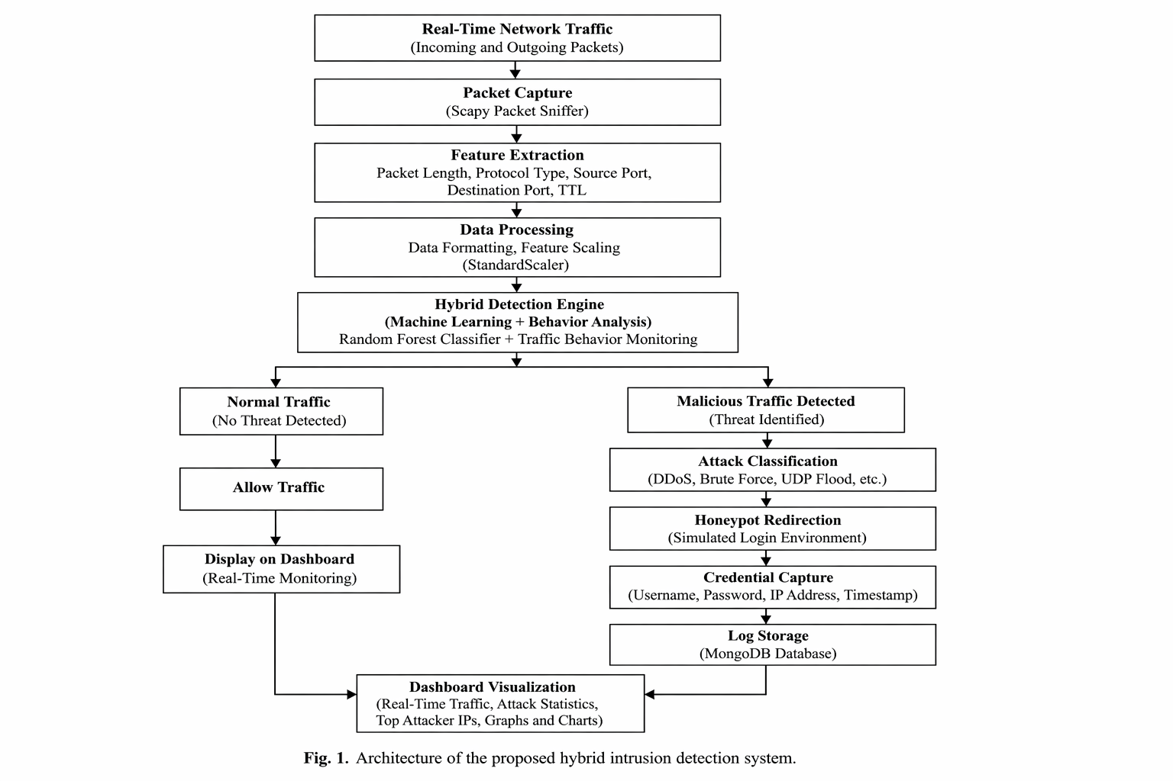
Figure 3.1: System Architecture Diagram

RESULTS AND DISCUSSION

Legal Assistant Output
The proposed AI-Powered Legal Assistant successfully analyzes legal queries and generates structured legal guidance in real time. The Streamlit-based interface provides a user-friendly environment where users can enter legal problems in natural language and receive relevant legal information instantly. The system successfully retrieves IPC sections, similar legal case laws, legal analysis, severity levels, and recommended legal actions.
The interface displays legal information in a structured format including legal domain classification, IPC section details, punishments, bailable status, and case law references. The integration of semantic retrieval and Large Language Models improves contextual understanding and generates meaningful legal responses for both citizens and lawyers.

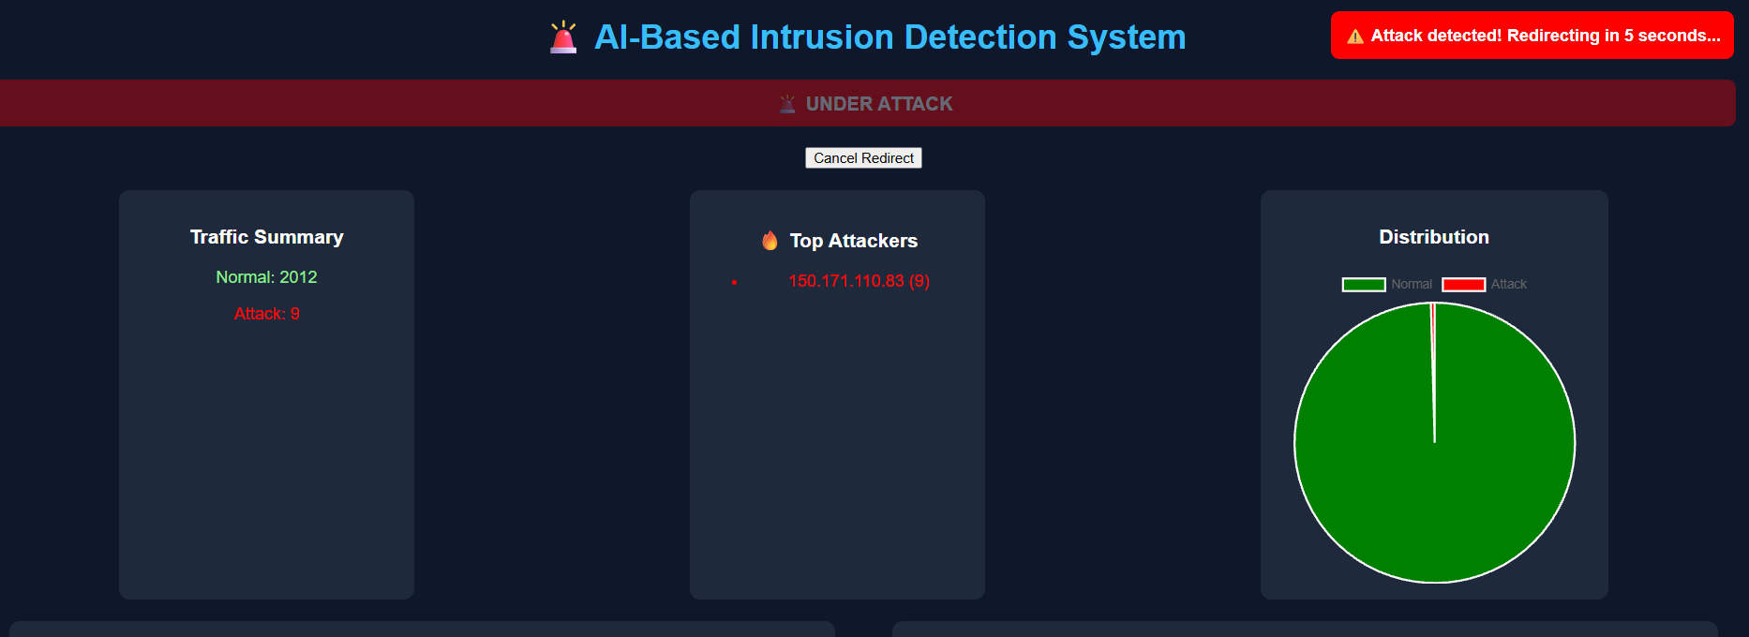
Figure 4.1: IDS Dashboard with Attack Detection

Similar Case Law Retrieval
The proposed system successfully retrieves similar legal case laws based on semantic similarity techniques. The Sentence Transformer model converts user queries and legal case datasets into vector embeddings and retrieves contextually relevant case laws using cosine similarity.
The system displays important case details such as case title, verdict summary, and source links for further legal reference. Similar case retrieval improves legal understanding and helps users identify legal precedents related to their legal problems. The retrieval mechanism provides better contextual matching compared to traditional keyword-based search systems.

Legal Analysis and Explanation
The reasoning module powered by LLaMA 3 successfully generates structured legal analysis and simplified legal explanations based on the retrieved IPC sections and case laws. The generated analysis explains the legal implications of the user query in a readable and understandable format.
The system also generates severity assessment and recommended legal next steps for users. In Citizen mode, explanations are simplified for easy understanding, while Lawyer mode provides more detailed legal reasoning and advanced legal insights.

Lawyer-Specific Features
The proposed AI-Powered Legal Assistant includes advanced lawyer-oriented features that improve legal analysis and legal decision support. In Lawyer mode, the system generates estimated legal timelines, cross-examination questions, document comparison insights, and legal probability predictions.
The estimated legal timeline provides information about possible investigation duration, trial stages, and expected legal procedures. Cross-examination question generation assists lawyers in preparing legal arguments and witness examination strategies. Legal probability prediction helps estimate possible legal outcomes such as conviction probability, bail probability, and settlement chances.
These advanced features improve the usefulness of the system for legal professionals and legal research purposes.



Figure 4.2: Honeypot Login Page

Semantic Retrieval Performance
The semantic retrieval module effectively identifies relevant IPC sections and legal case laws using embedding-based similarity search. The use of Sentence Transformers improves contextual understanding and allows the system to retrieve legally related information even when different wording is used in user queries.
During testing, theft-related queries retrieved IPC sections related to robbery and theft, while civil dispute queries retrieved property and ownership-related legal provisions. The retrieval performance demonstrated better contextual matching compared to traditional keyword-based legal search methods.
The retrieval mechanism also reduced irrelevant search results and improved the quality of legal information provided to users.

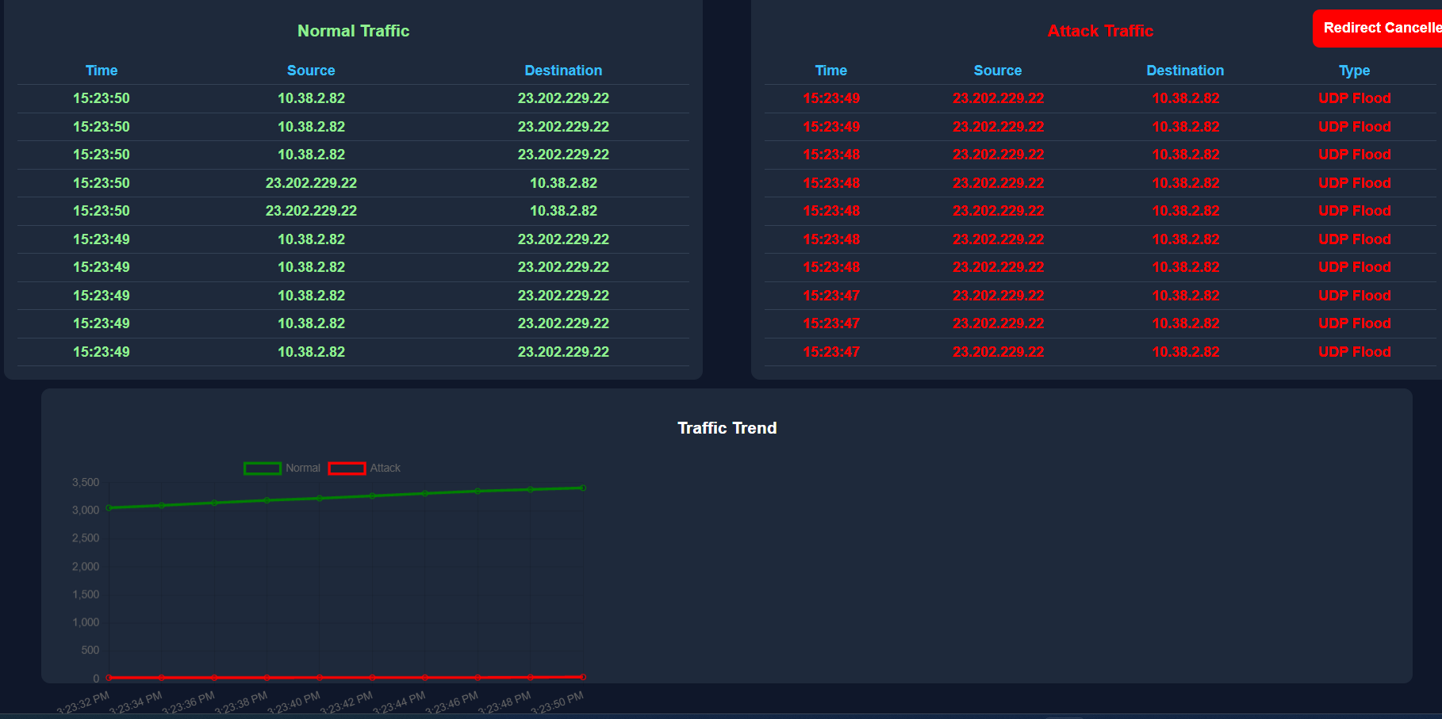

Figure 4.3: Traffic Logs and Trend Analysis

System Performance
The proposed AI-Powered Legal Assistant performs effectively in processing legal queries and generating structured legal responses in real time. The FastAPI backend handles API communication efficiently, while the Streamlit frontend provides smooth user interaction and response visualization.
The integration of semantic retrieval with Retrieval-Augmented Generation improves legal reasoning quality and reduces hallucinated responses. The system successfully generates contextual legal guidance for multiple legal domains including criminal law, civil disputes, consumer complaints, and cybercrime-related cases.
The overall results demonstrate that the proposed system provides intelligent legal assistance, contextual legal retrieval, and explainable legal reasoning using Artificial Intelligence and Large Language Models.

System Performance
The proposed AI-Powered Legal Assistant performs effectively in analyzing legal queries and generating structured legal guidance in real time. The semantic retrieval module accurately identifies relevant IPC sections and similar legal case laws based on contextual similarity. The integration of Retrieval-Augmented Generation further improves the quality and reliability of legal reasoning generated by the system.
The system efficiently processes user queries using FastAPI and displays responses through the Streamlit-based frontend without significant delay. The role-based interface successfully provides simplified legal explanations for citizens and advanced legal insights for lawyers. The lawyer-specific features such as legal timeline prediction, cross-examination question generation, and legal probability prediction improve the usefulness of the system for legal professionals.
Although the proposed system performs effectively for educational and small-scale legal assistance applications, handling extremely large legal datasets and highly complex legal reasoning tasks may require additional optimization and more advanced legal AI models in future implementations.

Advantages
The proposed AI-Powered Legal Assistant provides several advantages compared to traditional legal search systems and generic AI chatbots. The use of semantic retrieval techniques improves contextual understanding and allows the system to retrieve relevant IPC sections and case laws even when user queries are phrased differently.
The integration of Retrieval-Augmented Generation reduces hallucinated responses by grounding the Large Language Model with retrieved legal information. The system provides structured legal analysis, simplified explanations, severity assessment, and recommended legal actions in an understandable format.
The role-based interface improves usability for both citizens and legal professionals. Lawyer mode additionally provides advanced features such as estimated legal timelines, cross-examination questions, document comparison, and legal probability prediction. Overall, the proposed system improves legal information accessibility, reduces manual legal search effort, and enhances intelligent legal assistance.

Limitations
Although the proposed AI-Powered Legal Assistant performs effectively in legal query analysis and semantic legal retrieval, certain limitations still exist. The system mainly depends on the quality and coverage of the IPC and case law datasets used during retrieval operations. Limited datasets may reduce retrieval accuracy for highly specialized or uncommon legal cases.
The performance of the Large Language Model may also vary depending on the complexity of legal queries. Since the system currently uses a locally deployed LLaMA 3 model, highly complex legal reasoning or advanced legal interpretation may sometimes generate generalized responses. In addition, the system currently focuses mainly on legal assistance and guidance rather than official legal decision-making or legal automation.

Future improvements can address these limitations by integrating larger legal datasets, more advanced legal AI models, multilingual legal support, OCR-based document analysis, and real-time legal database integration.

CONCLUSION

Conclusion on results
The proposed AI-Powered Legal Assistant successfully demonstrates how Artificial Intelligence, semantic retrieval, and Large Language Models can improve legal information retrieval and legal assistance. The system accepts legal queries in natural language, retrieves relevant IPC sections and similar legal case laws, and generates structured legal analysis using Retrieval-Augmented Generation techniques.
The semantic retrieval module effectively improves contextual legal search while reducing irrelevant results. The LLaMA 3 reasoning module generates legal analysis, simplified explanations, severity assessment, and recommended legal actions in a structured and understandable manner. The role-based interface further improves usability by providing simplified legal support for citizens and advanced legal insights for lawyers.
The overall results demonstrate that the proposed system provides intelligent legal assistance, explainable legal reasoning, and improved accessibility to legal information using Artificial Intelligence and Natural Language Processing technologies.

Recommendations
The proposed AI-Powered Legal Assistant can be further improved by integrating larger and more comprehensive legal datasets containing additional IPC sections, case laws, court judgments, and legal precedents. This can improve retrieval accuracy and legal reasoning quality for complex legal scenarios.
More advanced Large Language Models and legal-specific AI models can also be integrated to improve contextual reasoning and reduce generalized responses. Additional features such as multilingual legal support, OCR-based legal document analysis, legal document summarization, and real-time legal database integration can further enhance the functionality of the system.
The system can also be optimized for large-scale legal information retrieval and enterprise-level legal assistance applications by improving scalability, response speed, and retrieval efficiency.

Future scope
The future scope of the proposed AI-Powered Legal Assistant includes the integration of advanced legal AI technologies and larger legal knowledge bases for more accurate and intelligent legal assistance. More advanced LLMs, legal reasoning models, and legal knowledge graphs can be used to improve contextual understanding and legal prediction capabilities.
Future improvements may also include multilingual legal support, voice-based legal interaction, OCR-based legal document analysis, automatic legal document generation, and court judgment summarization. Real-time integration with legal databases and government legal portals can further improve the reliability and usefulness of the system.
Additional features such as Explainable AI, adaptive legal learning systems, legal risk analysis, and AI-assisted legal research tools can further enhance the effectiveness of intelligent legal assistance systems in practical legal environments.

REFERENCES

- T. Sowmya and E. A. Mary Anita, "A comprehensive review of AI based intrusion detection system," *Measurement: Sensors*, vol. 28, p. 100827, 2023.[web:2]
- C. Park, J. Lee, Y. Kim, J.-G. Park, H. Kim, and D. Hong, "An enhanced AI-based network intrusion detection system using generative adversarial networks," *IEEE Internet of Things Journal*, vol. 10, no. 3, pp. 2330–2345, Feb. 2023.[web:2]
- R. Ahmad et al., "Enhancing database security through AI-based intrusion detection system," *Journal of Computing & Biomedical Informatics*, vol. 7, no. 2, Sep. 2024.[web:2]
- S. Rajapaksha et al., "AI-based intrusion detection systems for in-vehicle networks: A survey," *ACM Computing Surveys*, vol. 55, no. 11, Art. no. 237, 2023.[web:2]
- M. A. Hossain, "Deep learning-based intrusion detection for IoT networks: A scalable and efficient approach," *EURASIP Journal on Information Security*, vol. 2025, no. 1, p. 28, 2025.[web:2]
- S. Viharika and N. Balaji, "AI-driven intrusion detection systems in cloud infrastructures: A comprehensive review of hybrid security models and future directions," in *Proc. 4th Int.
Conf. Ubiquitous Computing and Intelligent Information Systems (ICUIS)*, 2024, pp. 1201– 1207.[web:2]
- R. Benameur, A. Dahane, S. Souihi, and A. Mellouk, "A novel federated learning based intrusion detection system for IoT networks," in *Proc. IEEE Int. Conf. Commun. (ICC)*, Denver, CO, USA, 2024, pp. 2402–2407.[web:2]
- O. Arreche, T. R. Guntur, J. W. Roberts, and M. Abdallah, "E-XAI: Evaluating black-box explainable AI frameworks for network intrusion detection," *IEEE Access*, vol. 12, pp. 23954– 23988, 2024.[web:2]
- B. Deore and S. Bhosale, "Hybrid optimization enabled robust CNN-LSTM technique for network intrusion detection," *IEEE Access*, vol. 10, pp. 65611–65622, 2022.[web:2]
- R. Saleem, W. Ni, M. Ikram, and A. Jamalipour, "Deep-reinforcement-learning-driven secrecy design for intelligent reflecting-surface-based 6G-IoT networks," *IEEE Internet of Things Journal*, vol. 10, no. 10, pp. 8812–8824, May
2023.[web:2]
- S. Ahmadi, "Autonomous identity-based threat segmentation for zero trust architecture," *Cyber Security and Applications*, vol. 3, p. 100106, 2025.[web:2]
- B. Abisha and V. S. Kumari, "An AI-driven network forensic framework using BERT and GPT for cybercrime investigation," in *Proc. 2025 Int. Conf. Intelligent and Secure Engineering Solutions (CISES)*, 2025, pp. 540– 545.[web:2]

PUBLICATION PROOF:

